Requêtes SQL

select customer_id, count(payment_id)as nb_location

from payment

group by customer_id

having count(*) >= ALL (SELECT count(*)

FROM payment

GROUP BY customer_id)

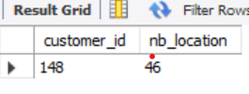

select count(payment_id)as nb_location,payment.customer_id,customer.last_name, customer.first_name,address.address,address.latitude,address.longitude

from dataengineer.payment ,customer,address,staff,store

where payment.customer_id=customer.customer_id

and store.address_id=address.address_id

and store.store_id= staff.store_id

group by payment.customer_id

having count(*) >= ALL (SELECT count(*)

FROM dataengineer.payment

GROUP BY payment.customer_id)

